Driving Question: How did the early Europeans impact the growth and development of the Okanagan Valley?
Prescribed Learning Outcomes
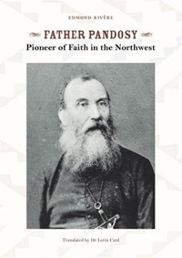
- Society and Culture:
  - Development of individual and group identity.
- Economy and Technology:
  - Exploration, trade, and settlement.
  - Growth of the fur trade.
- Environment:
  - Geographic regions of North America.
  - Exploration and trade routes.
  - Impact of physical environment on trade and settlement.
Benchmarks:
#1 Geographical region of Okanagan Valley (The Intermountain Range)
#2 Fur Trade and the Okanagan Fur Brigade Trail
#3 Early European Missionaries/Miners/Ranchers & Farmers in Okanagan Valley
#4 Early European settler in Okanagan Valley and his/her story

Backgrounder:
As you know, the west was opened up as a result of the fur trade. In the Okanagan we saw waves of Europeans coming to the area for a variety of different reasons. The missionaries arrived to spread their religious beliefs. People arrived because they heard about the money to be made in mining, ranching, and farming. Living in the Okanagan, you may know some of the first Europeans' names such as Pandosy or Knox but you may not know the history behind the names. Over the course of this project, you will learn about what brought the Europeans to this valley and eventually be able to answer the driving question.

Final Task: Visual presentation that could be used at the local Kelowna or Westbank museums or Tourism Kelowna booths.

Assessment Summative:
- Map of Region and characteristics of Okanagan Valley
- Written Paragraph (rubric) - Historical importance of Okanagan Fur Brigade Trail

- Written Test - Regions and Characteristics of Okanagan Valley, Okanagan Fur Brigade Trail, Missionaries, Miners, Ranchers and Farmers.
- Final Task - Visual Presentation for the Kelowna or West Kelowna Museums.
(see example and rubric)
- Presentations in small groups

Sequence of Lessons:

Lesson #1 Introduction to Unit. Overview and Hook (Scavenger Hunt) (1 lesson)

Lesson #2 Benchmark #1 (2 lessons)
  - 8 regions of North America
  - Geographical characteristics of Okanagan Valley
  - Map of Region

Lesson #2 Benchmark#2 (2 lessons)
- Okanagan Fur Brigade Trail - Historical significance to North American History.

Lesson #3 Benchmark #3 (2-3 lessons)
  - Early Europeans and key developments; The Missionaries, Miners, Ranchers and Farmers
  - Mini-Jigsaw

Lesson #4 Benchmark #4 (4-5 lessons)
- Final Task - Create a visual presentation that could be used at the Kelowna or West Kelowna Museum or Tourism Kelowna.
Final Task: To become an expert on one wave of Europeans (missionaries, miners or ranchers/farmers) into the Okanagan valley. You must also understand the story of how one early European person impacted the growth and development of the Okanagan Valley. Possible visual presentations could be a museum brochure, mini-poster, or informational newsletter.
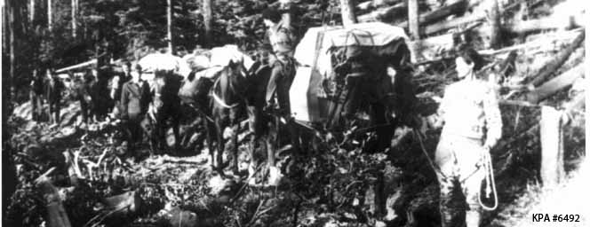 Picture of traders on the Okanagan Fur Bridge Trail

